ITA0601 – MACHINE LEARNING
LAB EXPERIMENTS
EXP 8: Linear Regression (LR) algorithm in python
Dataset 1 – House Price Prediction
House Size | House Price
800 | 32
1000 | 40
1200 | 52
1400 | 68
1600 | 88
1800 | 112
2000 | 140
2200 | 172
2400 | 208
2600 | 248
Python Code:
from sklearn.linear_model import LinearRegression
X = [[800], [1000], [1200], [1400], [1600],
[1800], [2000], [2200], [2400], [2600]]
y = [32, 40, 52, 68, 88, 112, 140, 172, 208, 248]
model = LinearRegression()
model.fit(X, y)
prediction = model.predict([[1700]])
print("House Size: 1700 sq.ft.")
print("Predicted House Price:", prediction[0], "Lakhs")
Output:
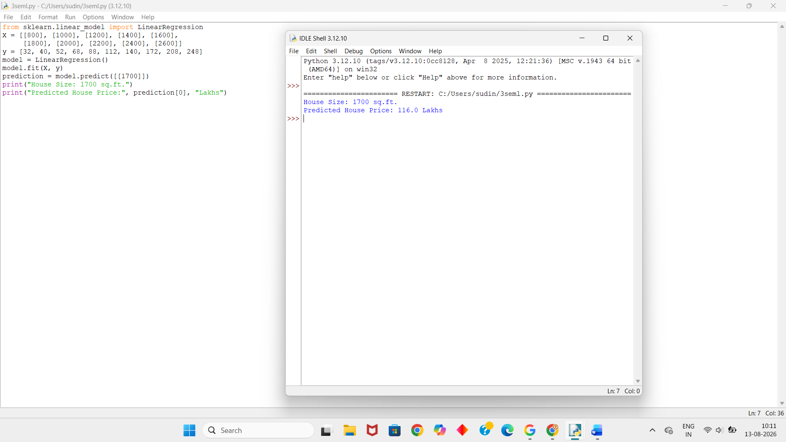

Dataset 2 – Student Marks Prediction
Study Hours | Exam Marks
1 | 18
2 | 30
3 | 43
4 | 57
5 | 68
6 | 78
7 | 86
8 | 91
9 | 95
10 | 98
Python Code:
from sklearn.linear_model import LinearRegression
X = [[1], [2], [3], [4], [5],
[6], [7], [8], [9], [10]]
y = [18, 30, 43, 57, 68, 78, 86, 91, 95, 98]
model = LinearRegression()
model.fit(X, y)
prediction = model.predict([[7.5]])
print("Study Hours: 7.5")
print("Predicted Exam Marks:", prediction[0])
Output:
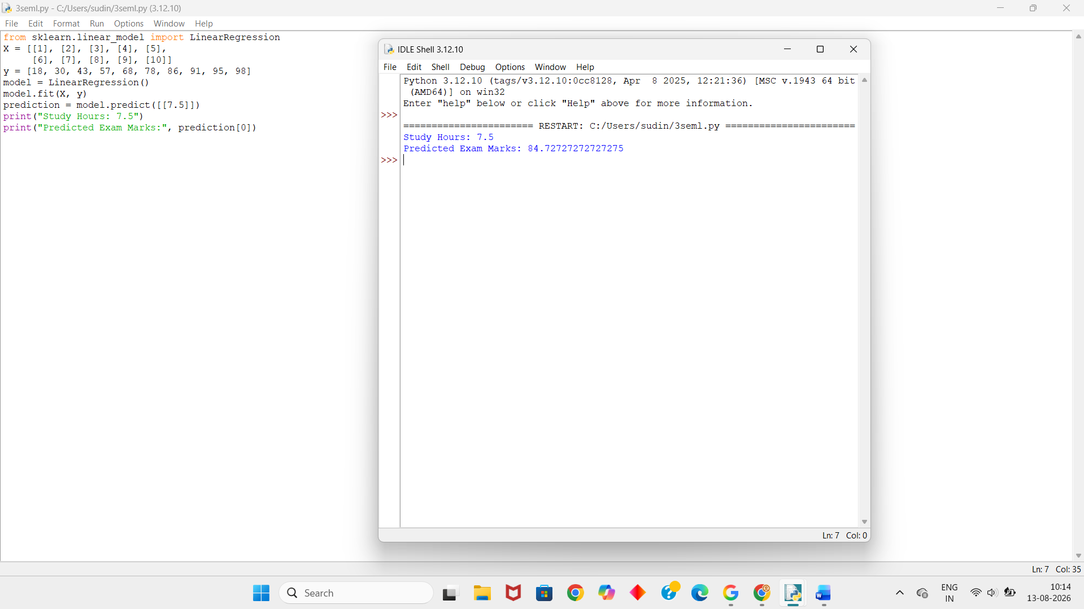
Dataset 3 – Car Speed and Fuel Consumption
Speed (km/h) | Fuel Consumption
40 | 4.5
50 | 4.8
60 | 5.2
70 | 5.9
80 | 6.8
90 | 8.0
100 | 9.5
110 | 11.2
120 | 13.4
130 | 16.0
Python Code:
from sklearn.linear_model import LinearRegression
X = [[40], [50], [60], [70], [80],
[90], [100], [110], [120], [130]]
y = [4.5, 4.8, 5.2, 5.9, 6.8,
8.0, 9.5, 11.2, 13.4, 16.0]
model = LinearRegression()
model.fit(X, y)
prediction = model.predict([[95]])
print("Speed: 95 km/h")
print("Predicted Fuel Consumption:", prediction[0])
Output:
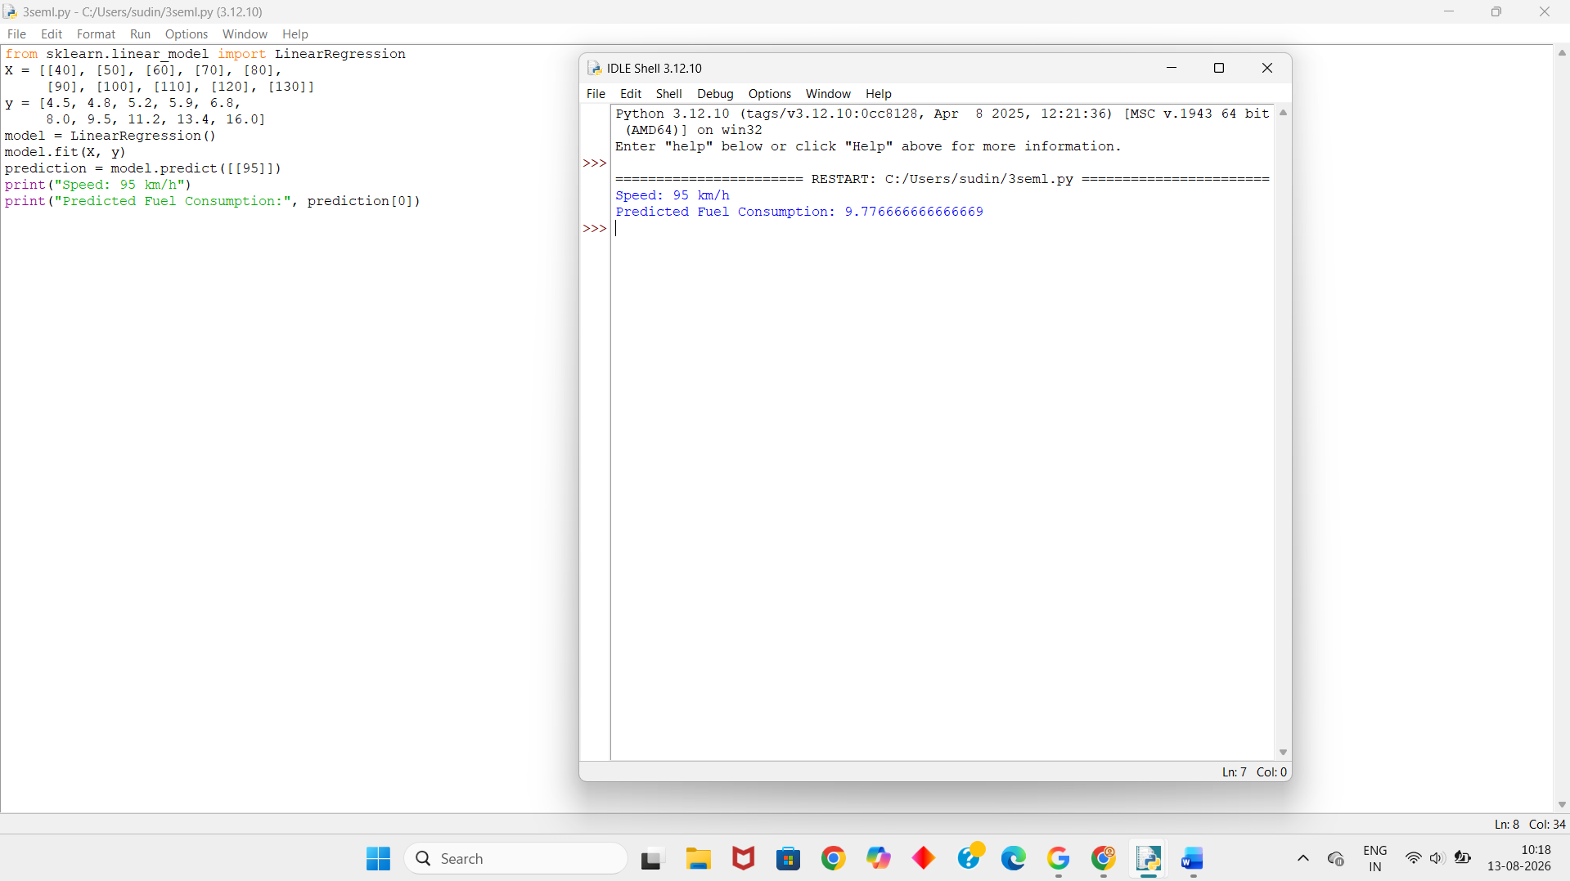
Dataset 4 – Advertising Cost and Sales
Advertising Cost | Sales
5 | 1.2
10 | 2.5
15 | 4.1
20 | 6.2
25 | 8.8
30 | 11.9
35 | 15.5
40 | 19.6
45 | 24.2
50 | 29.3
Python Code:
from sklearn.linear_model import LinearRegression
X = [[5], [10], [15], [20], [25],
[30], [35], [40], [45], [50]]
y = [1.2, 2.5, 4.1, 6.2, 8.8,
11.9, 15.5, 19.6, 24.2, 29.3]
model = LinearRegression()
model.fit(X, y)
prediction = model.predict([[32]])
print("Advertising Cost: 32 Lakhs")
print("Predicted Sales:", prediction[0], "Lakhs")
Output:
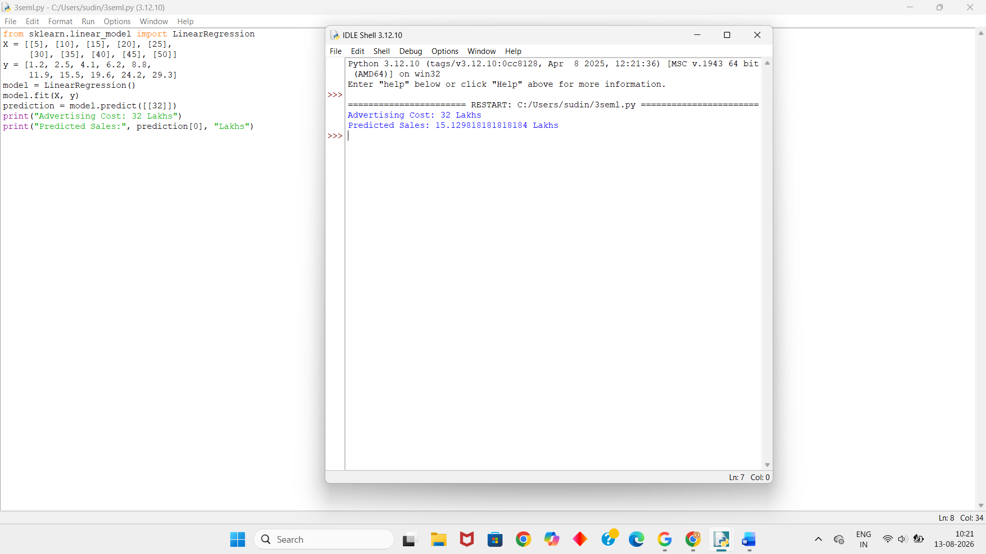
Dataset 5 – Employee Salary Prediction
Experience (Years) | Salary (₹ Lakhs)
1 | 3.0
2 | 3.8
3 | 4.9
4 | 6.3
5 | 8.0
6 | 10.2
7 | 12.9
8 | 16.1
9 | 19.8
10 | 24.0
Python Code:
from sklearn.linear_model import LinearRegression
X = [[1], [2], [3], [4], [5],
[6], [7], [8], [9], [10]]
y = [3.0, 3.8, 4.9, 6.3, 8.0,
10.2, 12.9, 16.1, 19.8, 24.0]
model = LinearRegression()
model.fit(X, y)
prediction = model.predict([[7.5]])
print("Experience: 7.5 Years")
print("Predicted Salary:", prediction[0], "Lakhs")
Output:
